Geography of Environmental Systems

Geography 201

Spring 2018

|  |  |
| --- | --- |
| Instructor: | Keith Yearwood2181 H Lefrak Hall(301) 405-4053kyearwoo@umd.eduMonday and Wednesday 11:00 am to 12:00 noon or by appointment |
| Office: |
| Phone: |
| Email: |
| Office Hours: |

|  |  |  |
| --- | --- | --- |
| Teaching Assistants: |  |  |
| Office: |  |  |
| Phone: |  |  |
| Email: |  |  |
| Virtual Office Hours: |  |  |
| In Person Office Hours: |  |  |

## Course Text

We are using *Elemental Geosystems*, 8th Edition, 2016, by Christopherson and Birkeland. You can purchase it from the bookstore as either: (1) a loose-leaf binder or (2) bound text. In either case it is bundled with Modified Mastering Geography, and includes access to the eText and the required Mastering Code. The Mastering Code purchase is required for the course. If you wish you can just purchase the eText with Mastering (option 3). The three options above are:

1. Elemental Geosystems, Books a la Carte Edition; Modified MasteringGeography with Pearson eText -- ValuePack Access Card, 8/E (loose-leaf). ISBN-10: 013419019X ISBN-13: 9780134190198

## Elemental Geosystems, Books a la Carte Edition; Modified MasteringGeography with Pearson eText -- ValuePack Access Card, 8/E (bound). ISBN-10: 0134396316 ISBN-13: 9780134396316

1. ModifiedMasteringGeography with Pearson eText – Standalone Access Card – for Elemental Geosystems, 8/E. ISBN-10: 032199457

## Course Background

Geography 201 is an introduction to physical geography, a natural science allied with sciences such as geology, climatology, meteorology, oceanography, hydrology botany and agronomy. The geographic perspective is unique in that it integrates not only the individual systems that have commonly been associated with a single discipline, but also the interaction of these systems within a framework we call *Earth System Science*. The major goal of this class is to provide a fundamental understanding of the physical environment we live in. In doing so, the course will provide the basis for comprehending modern environmental issues, including those affected by human activities.

**Knowledge Objectives**

At the completion of our course, we should be able to describe the basic elements of physical geography, including the following:

1. The Earth’s revolution around the Sun and its impact on energy, temperature, and seasons.
2. The Earth’s global energy balance and its variability by latitude and seasons
3. The factors that control air temperature and its variability, and the science behind global warming.
4. The role of water in the atmosphere and its importance in the hydrologic cycle.
5. The formation of clouds, weather systems and severe storms.
6. The formation winds, from local to global scales, and the impact of air pressure and coriolis force on these.
7. How the climates of the Earth are classified.
8. The processes that control the rock cycle and plate tectonics.
9. The formation of landforms, including volcanoes, tectonic features, and earthquakes.
10. The processes that reduce landforms, including weathering and mass wasting, and those which shape them through running water, wind and ice.
11. The formation, classification and geographic distribution of soils.
12. The fundamental biogeographic processes and how these shape the global distribution of plants and animals.
13. Specific knowledge of current environmental issues including global warming, sea-level rise, impacts of severe storms, air-pollution, water pollution, soil degradation, and loss of biodiversity, and the key processes in physical geography that underlay them.

**Learning Outcomes**

1. To understand the fundamental laws and principles underlying the physical environment, how these control processes that occur on the land surface, in the oceans and in the atmosphere, and how these systems interact.
2. To understand the mechanisms that lead to variability in important physical characteristics such as air temperature, weather, climate, landforms, soils, plants and other elements of the environment
3. To develop a basic understanding of the geographic perspective as applied to earth system science.
4. To develop the foundational learning of environmental science and the scientific method that enables critical thinking about the many pressing environmental problems facing society in the coming decades.

## Course Organization

The course is organized around the four basics systems of the Earth: the energy-atmosphere system, the hydrosphere, the lithosphere and the biosphere. We will follow the general outline of book and cover each chapter in sequence. Lectures will highlight key concepts in our text as well as a number of special topics. We will also present some material that is not in the text.

Geography 201 is a *Mastered* course using the content of Pearson’s MyLab and Modified Mastering (abbreviated as ML&M) available via Canvas. We will experiment with various aspects of ML&M during the semester. The ML&M site has various learning components, including self-tests, adaptive learning, videos and other media. In addition, graded online quizzes will be assigned in ML&M.

The course will be taught using graphics and notes in PowerPoint, as well as notes written by hand during lecture. The PowerPoint slides will be made available on Canvas, but not the hand-written notes. These materials and all lecture notes taken during class are copyrighted by the University and may not be reproduced or disseminated without the written permission of the instructor. In addition, no audio taping of lectures is allowed without the written permission of the instructor.

## Course Requirements

There is no explicit attendance requirement for our course. However, students should browse each chapter. There will be two midterms and a comprehensive final exam, but the final will be weighted towards the material not covered on the first two midterms.

**Course Grading**

Course grades will be determined as the sum of the weighted scores of any in-class assessments, assigned work on ML&M, the two midterms and final. Exams generally consist of short answer diagram and multiple choice questions. Grades are assigned as follows:

|  |  |
| --- | --- |
| Final Percentage | Grade |
| 96-100 | A+ |
| 92-95 | A |
| 90-91 | A- |
| 88-89 | B+ |
| 82-87 | B |
| 80-81 | B- |
| 78-79 | C+ |
| 72-77 | C |
| 70-71 | C- |
| 60-69 | D |
| Less than 60 | Fail |

Final Grade Components

|  |  |
| --- | --- |
| ML&M Reading Quizzes | 15% |
| Midterm #1 | 25% |
| Midterm #2 | 25% |
| Final Examination | 35% |

## ELMS places a default grade by adding all your scores and calculating the percentage of that grand score out of the total possible points. That is not how grades are calculated in this course. For example, for the first Midterm exam, a student who gets 51 out of 65 should calculate their scores by dividing 51 by 65 and then multiplying that value by 25. This should be done for both midterm exams. For the final exam, instead of multiplying the value by 25, students must multiply the value by 35. The final percentage is obtained by adding each of those scores plus the mastering section which is worth 15 percent.

## CORE Laboratory Science Requirement

Geography 201, when taken concurrently with Geography 211, fulfills the CORE Laboratory Science Requirement. Geography 201/211 ***must*** be taken in the same semester to meet this requirement. Geography 201 by itself does ***not*** count as a non-lab science for CORE.

**Academic Integrity**

The University of Maryland, College Park has a nationally recognized Code of Academic Integrity, administered by the Student Honor Council. This Code sets standards for academic integrity at Maryland for all undergraduate and graduate students. As a student you are responsible for upholding these standards for this course. It is very important for you to be aware of the consequences of cheating, fabrication, facilitation, and plagiarism. **Please note well:** Each student must complete their own online Mastering work, by themselves. Unless specifically directed, working collaboratively on the ML&M graded components is a violation of academic integrity and will be treated very seriously (possibly resulting in a grade of “XF”). For more information on the Code of Academic Integrity and the Student Honor Council, please visit the Student Honor Council website to see [Code of Academic Integrity](http://shc.umd.edu/SHC/StudentAcademicDishonesty.aspx).

**STUDENTS WITH SPECIAL NEEEDS AND COUNSELING FOR STUDENTS WITH SPECIAL NEEDS:**  If you are a student who has special needs that have been recognized by the University of Maryland at College Park, please see your instructor immediately so that arrangements can be made for you to maximize the chances for you to successfully complete this course.  If you experience difficulties in mastering the academic demands of this course, please contact the Learning Assistance Service, 2201 Shoemaker Building, 301-314-7693 as soon as possible.  Their educational counselors can provide assistance with time management, reading, note-taking, and exam preparation skills.

**DISABILITIES:**We will make every effort to accommodate students who are registered with the Disability Support Services (DSS) Office and who provide me with a University of Maryland DSS Accommodation form.  This form must be presented to the Instructor as early as possible.  We will not be able to accommodate students who are not registered with DSS or who do not provide me with documentation, which has been reviewed by DSS after this date

**RELIGIOUS OBSERVANCE:**By February 15th, students must provide the instructor in writing a request for a request for a make-up exam if you are unable to take an exam on the scheduled date due to a specific religious observance (specify). In addition, written requests must also be made for turning in a discussion assignment late or missing a discussion because of a specific religious observance. Please refer to the Online Undergraduate Catalog Policy on Religious Observance

**Absences**

The most effective way to learn the material in this course is to attend *every* lecture. Students are therefore advised to attend each lecture even though all the notes in the class will be available on line through ELMS. Missing exams owing to illnesses, students are required to bring a sick note documented by a health care professional and an appropriate time will be arranged for the student to take the exam that was missed. The documentation must specify the dates for which the absences are excused.

**Policy on General Lecture Behavior**

Students are expected to be considerate of their fellow classmates and the instructors during lecture. This includes no talking, no reading of newspapers, or other distracting behavior. If you arrive late for class, please enter the classroom by the rear lecture room doors. If you must use the washroom during lecture please enter and exit by the rear doors.

**Class Schedule**

|  |  |  |
| --- | --- | --- |
| Dates | Topic | Readings |
| Jan 25 | Introduction and Essentials of Geography | Chapter 1 |

|  |  |  |
| --- | --- | --- |
| PART I: The Energy-Atmosphere System | | |
| Jan 30 | Solar Energy, Seasons and Atmosphere | Chapter 2 |
| Feb 1, 6 | Atmospheric Energy and Global Temperatures | Chapter 3 |
| Feb 8, 13 | Atmospheric and Oceanic Circulations | Chapter 4 |

|  |  |  |
| --- | --- | --- |
| PART II: Weather, Water and Climate Systems | | |
| Feb 15, 20, 22 | Atmospheric Water and Weather | Chapter 5 |
| Feb 27, Mar 1, 6 | Water Resources | Chapter 6 |
| Mar 8 | ***First Midterm Exam*** | Chapters 1-6 |
| Mar 13 | Earth’s Climatic Regions and Climate Change | Chapters 7, 8 |

|  |  |  |
| --- | --- | --- |
| PART III: Landforms and Geomorphology | | |
| Mar 15, 27 | The Dynamic Planet | Chapter 9 |
| Mar 29, Apr 3 | Tectonics, Earthquakes and Volcanism | Chapter 10 |
| April 5 | Weathering, Karst Landscapes and Mass Movement | Chapter 11 |
| April 10, 12 | River Systems | Chapter 12 |
| April 17, | **Second Midterm Exam** | Chapter 7-12 |
| April 19, 24 | Oceans, Coastal Systems and Wind Processes | Chapter 13 |
| April 26 | Glacial and Periglacial Landscapes | Chapter 14 |

|  |  |  |
| --- | --- | --- |
| PART IV: Ecosystem Processes | | |
| May 1 | The Geography of Soils | Chapter 15 |
| May 3 | Ecosystem Essentials | Chapter 16 |
| May 8, 10 | Terrestrial Biomes | Chapter 17 |

|  |  |  |
| --- | --- | --- |
| To be decided | **Final Exam** | Chapters 1-17 |

**Important Dates**

First Midterm Examination: Thursday, March 8th

Second Midterm Examination: Tuesday, April 17th

Final Examination: to be decided

**A note on querying exam scores**: Students are free to query their exam scores under the following conditions:  You cannot query scores from a previous exam after a second exam is given, etc.  Your window of opportunity therefore lasts from the end of the exam until the time the next one is given.

**PLEASE BE ADVISED THAT THE MATERIAL OUTLINED IN THE SYLLABUS, INCLUDING DATES FOR EXAMS ARE SUBJECT TO CHANGE IN ACCORDANCE WITH THE OCCURRENCE OF SPECIAL CASES AND EVENTS.**

**MyLab and Modified Mastering**

Please follow the directions on the following page below to access ML&M through Canvas.

We have a provided a suggested workflow to help guide you through using ML&M.

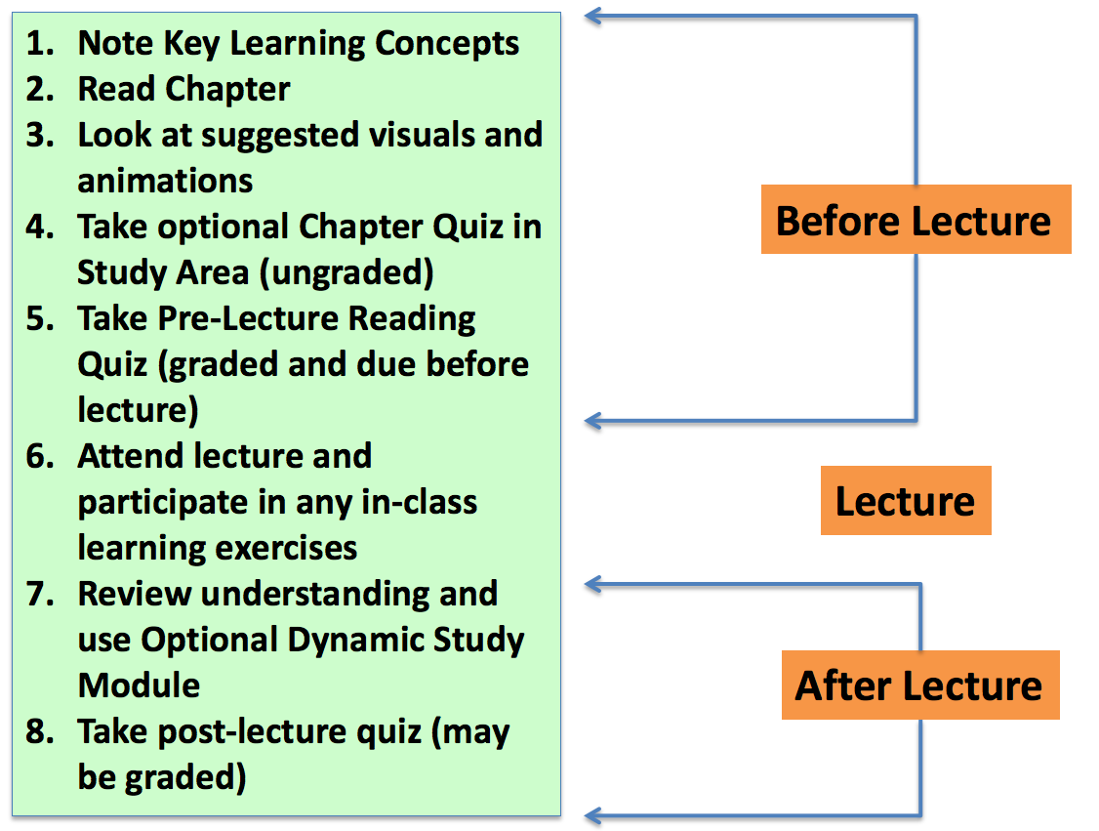***Before Lecture***:

Before you start reading the chapter, first note the Key Learning Concepts as they will help guide your reading. Next, read the chapter and look at any suggested visuals, animations and other media on ML&M. If desired, take the ungraded chapter quiz (note this is *not* the same as the graded reading quiz).

***During Lecture:***

Attend lecture, and participate in any in-class learning exercises. Take notes on any new material that is provided in class, as well as noting any concepts that are not clear.

***After Lecture:***

Review your understanding (clear up any questions from class or readings), and consider using the adaptive learning Dynamic Study Material (these are never graded). Finally, take the post-lecture quiz if provided (which may be graded).

Dynamic Study Modules can be accessed using the “Study Area” tab in your MyLab and Mastering area of Canvas. All practice quizzes, videos and additional materials are available from there. The modules are assigned based on the corresponding chapter in the book.

|  |  |  |
| --- | --- | --- |
| Module | Topic | Readings |
| Module 1 | Essentials of Geography | Chapter 1 |

|  |  |  |
| --- | --- | --- |
| PART I: The Energy-Atmosphere System | | |
| Module 2 | Solar Energy, Seasons and Atmosphere | Chapter 2 |
| Module 3 | Energy Balance and Temperature | Chapter 3 |
| Module 4 | Atmospheric and Oceanic Circulation | Chapter 4 |

|  |  |  |
| --- | --- | --- |
| PART II: Weather, Water and Climate Systems | | |
| Module 5 | Atmospheric Water and Weather | Chapter 5 |
| Module 6 | The Hydrologic Cycle and Water Resources | Chapter 6 |
| Module 7 and 8 | Climate and Climate Change | Chapters 7, 8 |

|  |  |  |
| --- | --- | --- |
| PART III: Landforms and Geomorphology | | |
| Module 9 | Earth Structure and Plate Tectonics | Chapter 9 |
| Module 10 | Volcanic and Tectonic Landforms | Chapter 10 |
| Module 11 | Weathering and Mass Wasting | Chapter 11 |
| Module 12 | River Systems and Landforms | Chapter 12 |
| Module 13 | Landforms Made by Waves and Wind | Chapter 13 |
| Module 14 | Glacial and Periglacial Landforms | Chapter 14 |
| PART IV: Ecosystem Processes | | |
| Module 15 | Soils | Chapter 15 |
| Module 16 | Biogeographic Processes | Chapter 16 |
| Module 17 | Global Biogeography | Chapter 17 |

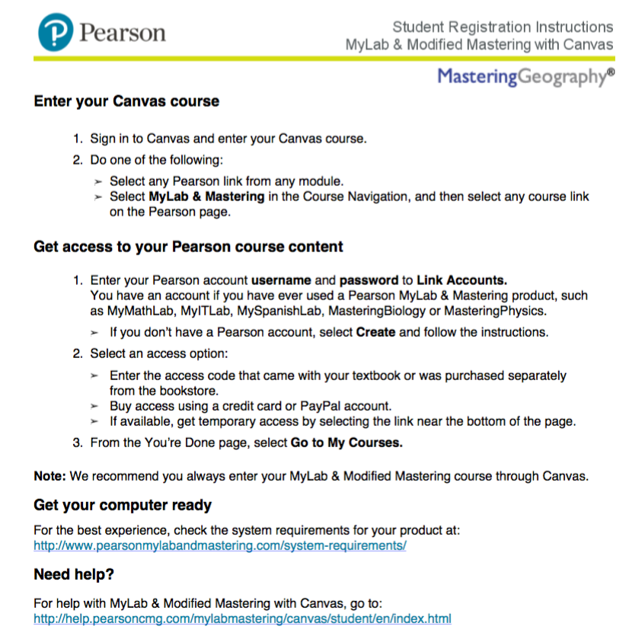

Please note. Always enter the ML&M content through Canvas, as opposed to going directly through.