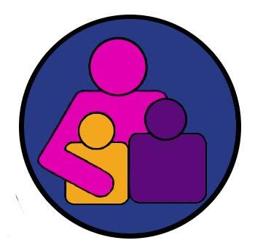
CENTER FOR CHILDREN, RELATIONSHIPS, AND CULTURE, DEVELOPMENTAL SCIENCE FIELD COMMITTEE, & VP Office for Research CO-SPONSORED COLLOQUIUM SERIES
Fall 2018
12:00 to 1:45, Wednesdays, 1107 Benjamin Building, U. of Maryland, College Park

Tracy Sweet
University of Maryland

Modeling Social Networks as Mediators

Join us!

Wednesday, November 14, 2018
12:00 – 1:45pm
Room 1107, Benjamin Building

Melanie Killen (mkillen@umd.edu) and Lucas Butler (lpbutler@umd.edu) are the faculty coordinators and Alexander D’Esterre (desterre@umd.edu) is the graduate student coordinator for the Center Seminar, Fall 2016.

